Microgame Jam Tutorial (temp version)

Thank you for participating in the Microgame Jam! Something something

Things I think should be written:

* This is a beginner jam intended for ppl who haven’t made a full game yet
* Godot only, use the template
* 4-8 second microgame
* You will have from date 1 to date 2 to make the gane, submit by date 2
* Come to the tutorial on tutorial date for step-by-step guide on properly making the game!
* Prizes will be offered

This doc looks kinda ugly and hopefully we can update it later lol

# Step 1

Import and edit the project by finding the project.godot file.

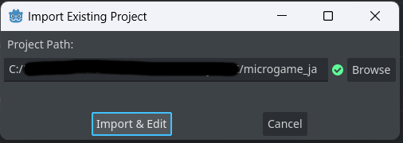

# Step 2

Make a new folder for your microgame and make a new Node2D that will be your microgame.

Make a new script for your microgame – the main script

MOST IMPORTANT PART: make sure your microgame extends the Microgame class. This makes it so that it has all the settings for a microgame and can interface with the main game.

Extending Microgame exposes a lot of new settings in the inspector for your game.

Microgame info is just general stuff you can fill out.

Important microgame settings

**Game length:** how long your game will be before timing out (in seconds)

**Lose on timeout:** specifies whether your game will lose/win when the time runs out

**Message:** A small message that will appear before your game starts, make it short and memorable and maybe with a small instruction

**Control Type:** specify which controls your game uses. Three options: mouse, WASD, or both. Will show up in the main game below the message

Last part, one that’s essential. Gonna need a bomb timer for your microgame

Add a new bomb timer to ur game

Position it in a reasonable spot

And make sure to set it as the script’s bomb timer

There is also another way to win/lose before the timer is up. Just emit the win_game and lose_game signals, this is an example:

Once you are done your microgame, you can add it to the main game by increasing the microgame list size and adding ur game to the list

